

**Examination, 2019**

**Question/Answer Booklet**

ECONOMICS Unit 3 Semester 1, 2019

|  |  |  |  |  |  |  |  |  |  |
| --- | --- | --- | --- | --- | --- | --- | --- | --- | --- |
|  |  |  |  |  |  |  |  |  |  |

**Student Number: In figures**

**In words:**

|  |
| --- |
|  |
|  |

**Time allowed for this paper**

Reading time before commencing work: ten minutes

Working time for paper: three hours

**Materials required/recommended for this paper**

***To be provided by the supervisor***

This Question/Answer Booklet

2 x Extended Response Answer Booklet

Multiple-choice Answer Sheet

***To be provided by the candidate***

Standard items: pens (blue/black preferred), pencils (including coloured), sharpener,

correction fluid/tape, eraser, ruler, highlighters

Special items: non-programmable calculators approved for use in the ATAR examinations

**Important note to candidates**

No other items may be taken into the examination room. It is **your** responsibility to ensure that you do not have any unauthorised material. If you have any unauthorised material with you, hand it to the supervisor **before** reading any further.

**Structure of this paper**

|  |  |  |  |  |  |
| --- | --- | --- | --- | --- | --- |
| Section | Number of questions available | Number of questions to be answered | Suggested working time (minutes) | Marks available | Percentage of examination |
| Section One:  Multiple-choice | 24 | 24 | 30 | 24 | 24 |
| Section Two:  Data interpretation / Short response | 3 | 3 | 70 | 36 | 36 |
| Section Three:  Extended response | 4 | 2 | 80 | 40 | 40 |
|  |  |  |  | **Total:** | 100 |

**Instructions to candidates**

1. Answer the questions according to the following instructions.

**Section One**: Answer all questions on the separate Multiple-choice Answer Sheet provided. For each question shade the box to indicate your answer. Use only a blue or black pen to shade the boxes. If you make a mistake, place a cross through that square, then shade your new answer. Do not erase or use correction fluid/tape. Marks will not be deducted for incorrect answers. No marks will be given if more than one answer is completed for any question.

**Section Two**: Write your answers in this Question/Answer booklet.

**Section Three**: Write your answers in the Extended Response Answer booklet. Start each question in a separate booklet.

2. You must be careful to confine your responses to the specific questions asked and to follow any instructions that are specific to a particular question.

3. Supplementary pages for the use of planning/continuing your answer to a question have been provided at the end of this Question/Answer booklet. If you use these pages to continue an answer, indicate at the original answer where the answer is continued, i.e. give the page number.

**Section One: Multiple Choice (24 Marks)**

This section has **24** questions. Answer **all** questions on the separate Multiple-choice Sheet.

For each question shade the box to indicate your answer. Use only a blue or black pen to shade the boxes. If you make a mistake, place a cross through that square, then shade your new answer. Do not erase or use correction fluid/tape. Marks will not be deducted for incorrect answers. No marks will be given if more than one answer is completed for any question.

Suggested working time: **30** minutes.

___________________________________________________________________

1. Globalisation is beneficial for firms because it

(a)  protects them against foreign competition.

(b)  cushions them from the effects of events in other countries.

(c)  opens up new market opportunities.

(d)  increases the risk and uncertainty of operating in a globalising world economy.

2. Which of the following is a factor that affects international competitiveness?

(a) Relative prices of imports

(b) Relative price level

(c) Changes in rates of economic growth

(d) Changes in the trade balance

3. Which of the following accurately reflects Australia’s top 3 exports?

(a) Gold, iron ore, coal

(b) Iron ore, coal, education-related travel services

(c) Education-related travel services, iron ore, gold

(d) Personal travel services, gold, crude petroleum

4. The value of trade between countries *A* and *B* increases while the value of trade between countries *A* and *C* decreases. All other things being equal, this most likely occurred because country *A*

(a) implemented a free trade agreement with country *B*.

(b) implemented a free trade agreement with country *C*.

(c) raised import tariffs on both country *B* and country *C*.

(d) reduced import tariffs on both country *B* and country *C*.

5. All of the following are sources of comparative advantage *except*

(a) climate and natural resources.

(b) relative abundance of labor and capital.

(c) technology.

(d) a strong foreign currency exchange rate.

6. The table shows the annual production per worker per year in three countries. There are no trade barriers, no transport costs and the countries specialise on the basis of opportunity cost.

|  |  |  |  |
| --- | --- | --- | --- |
| Product (tonnes) | Southland | Westland | Eastland |
| Apples | 100 | 80 | 12 |
| Wheat | 80 | 70 | 16 |
| Rice | 60 | 60 | 8 |

Which country will export which product?

|  |  |  |  |
| --- | --- | --- | --- |
|  | Southland | Westland | Eastland |
| (a) | Rice | Apples | Wheat |
| (b) | Apples | Rice | Wheat |
| (c) | Wheat | Rice | Apples |
| (d) | Apples | Wheat | Rice |

7. If supporters of restrictions on imports argue that protection is needed to preserve a strategic industry; which of the following is being used?

(a) Save domestic jobs argument.

(b) National security argument.

(c) Dumping argument.

(d) Infant-industry argument.

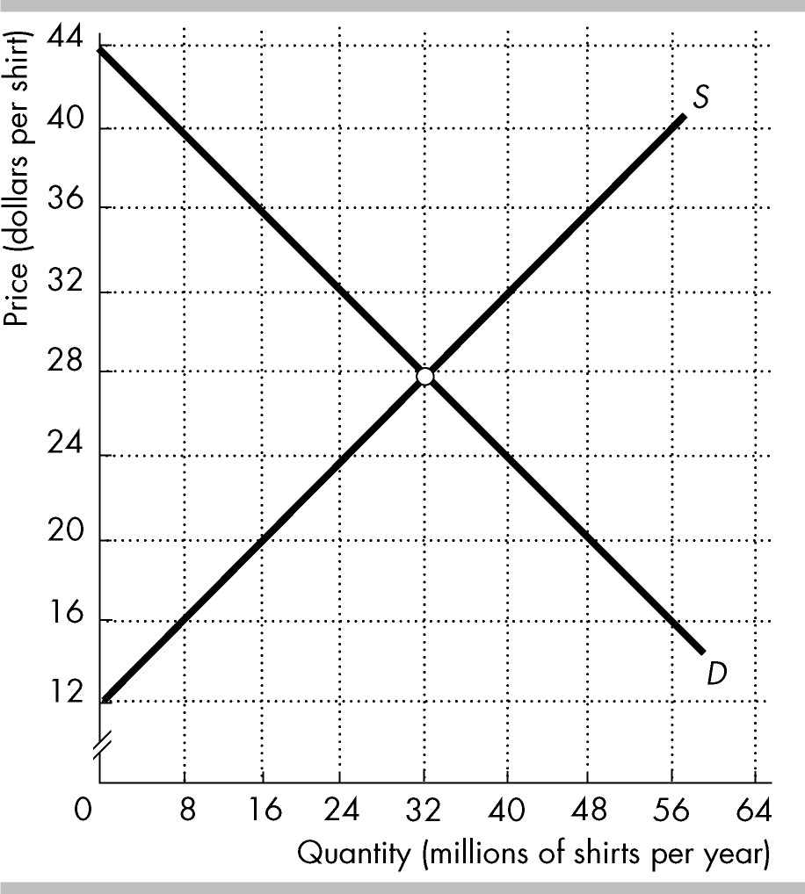8. The figure shows the market for shirts in an economy, where D is the domestic demand curve and S is the domestic supply curve. The world price is $20 per shirt. The country imposes a tariff on imported shirts of $4 per shirt.

The tariff ________ imports of shirts by ________ million shirts per year.

(a) decreases; 16

(b) decreases; 8

(c) increases; 16

(d) increases; 8

9. What are Australia's two main imports?

(a) personal travel and telecom equipment

(b) education services and computers

(c) passenger motor vehicles and refined petroleum

(d) personal travel and passenger motor vehicles

|  |  |
| --- | --- |
| Current Account | $ million |
| Exports | 5800 |
| Imports | 5500 |
| Net Services | –800 |
| Net Income | –400 |

10. This question relates to the table opposite.

The balance on the capital and financial account is

(a) $400 million.

(b) $500 million.

(c) $900 million.

(d) -$900 million.

11. Fluctuations in the current account balance are mainly the result of fluctuations in

(a) net interest.

(b) foreign reserves.

(c) net income.

(d) net exports.

12.Which of the following could lead to an increase in the cyclical component of Australia’s current account deficit?

(a) An increase in net foreign liabilities

(b) An increase in the investment-savings gap

(c) A decrease in exports due to a weakening global economy

(d) An increase in exports resulting from an improvement in the terms of trade

13. Suppose BHP Billiton purchases a gold mine in Canada. In Australia’s balance of payments, this purchase would be entered into the___________ account while the dividends from the mine would be entered into the __________ account

(a) financial; current

(b) current; financial

(c) financial; trade

(d) capital; income

14. In December 2016, Australia’s Current Account Deficit decreased significantly. This was due to:

1. a significant increase in trade balance and a decrease in dividend payments to

overseas investors.

1. a significant decrease in Australia’s terms of trade and a decrease in foreign

liabilities.

(c) a depreciation of the Australian dollar and an increase in foreign investment.

(d) a decrease in commodity prices and a significant increase in income payments to overseas investors.

 15. Which of the following would be likely to occur if the Australian dollar depreciates significantly against the currencies of its trading partners?

(a) A fall in the quantity of goods exported from Australia

(b) An increase in imported inflation into Australia

(c) An increase in the quantity of goods imported into Australia

(d) A fall in the cost of travelling overseas from Australia

16. You are traveling in Germany and are thinking about buying a new digital camera. You have decided you would be willing to pay $125 for a new camera, but cameras in Germany are all priced in euros. If the camera you are looking at costs 115 euros, under which of the following exchange rates would you be willing to purchase the camera?

(a) 0.76 euros per dollar

(b) 0.88 euros per dollar

(c) 0.93 euros per dollar

(d) You would purchase the new camera at any of the above exchange rates.

17. Refer to the table below:

|  |  |  |
| --- | --- | --- |
| *Year* | *Import price index* | *Export price index* |
| 1 | 100 | 100 |
| 2 | 104 | 117 |

Which of the following accurately represents an impact of the change in the terms of trade from Year 1 to Year 2 most likely means that, for this country:

(a) the exchange rate will fall.

(b) the current account deficit will rise.

(c) real income levels will increase.

(d) fewer imports will be bought within the country.

18. Which of the following best explains the changes in the TOT and the TWI from Year 1 to Year 2?

|  |  |  |
| --- | --- | --- |
| *Year* | *Terms of trade (TOT)* | *Trade weighted index (TWI)* |
| 1 | 100 | 50 |
| 2 | 110 | 60 |

(a) There is an increase in global demand for the goods this economy exports and imports.

(b) The economy’s central bank has decreased interest rates relative to global interest rates.

(c) The domestic demand for imports has increased relative to the global demand for the goods this economy exports.

(d) Global demand for the goods this economy exports has increased relative to domestic demand for the goods this economy imports.

19. ________________ investment is the flow of funding provided by an investor to establish or acquire a foreign company or to expand or finance an existing foreign company that the investor owns or controls.

(a)      International portfolio

(b)      International capital

(c)      Foreign direct

(d)      Foreign indirect

20. In the short term, a decrease of foreign investment into Australia will

(a) depreciate the dollar and increase the current account deficit.

(b) depreciate the dollar and decrease the financial account balance.

(c) appreciate the dollar and increase imports.

(d) increase the current account balance by boosting imports.

21. Currency traders expect the value of the Australian dollar to fall. What effect will this have on the demand for and the supply of Australian dollars in the foreign exchange market?

(a) Demand for dollars will increase, and supply of dollars will decrease.

(b) Demand for dollars will increase, and supply of dollars will increase.

(c) Demand for dollars will decrease, and supply of dollars will decrease.

(d) Demand for dollars will decrease, and supply of dollars will increase.

22. There is a significant increase in official interest rates in the United States of America (US). All other things being equal, which of the following would be true?

(a) There would be increased supply of $AUD and the $AUD would depreciate.

(b) There would be decreased supply of $AUD and the $AUD would appreciate.

(c) There would be increased demand for $AUD and the $AUD would depreciate.

(d) There would be decreased demand for $AUD and the $AUD would appreciate.

23. Which of the following would help to reduce Australia's foreign debt?

(a) An increase in the rate of domestic saving

(b) An increase in net foreign liabilities

(c) An increase in the level of foreign investment into the Australian economy

(d) An increase in the current account deficit

24. There is an appreciation in the exchange rate of the AUD$. Which would cause the greatest increase in Australia’s current account deficit?

(a) A rise in the terms of trade

(b) A high price elasticity of demand for imports

(c) A low price elasticity of demand for exports

(d) A low rate of domestic inflation

***End of Section One***

**Section Two: Data interpretation/Short response (36 Marks)**

This section contains **three (3)** questions. Answer **all** questions. Write your answers in the spaces provided.

Supplementary pages for the use of planning/continuing your answer to a question have been provided at the end of this Question/Answer booklet. If you use these pages to continue an answer, indicate at the original answer where the answer is continued, i.e. give the page number.

Suggested working time: **70** minutes.

__________________________________________________________________

**Question 25 (12 marks)**

**Gains in the AUD/USD value**

The **AUD/USD** pair trades near 0.7015 during early Asian sessions on Friday (25th April 2019). The Aussie pair managed to hold recent gains after ANZAC day holiday on Thursday while traders await domestic data. Also in the spotlight will be the on-going trade talks between the US and China together with the US Q1 2019 GDP.

The Australian Dollar (AUD) benefited from the market’s profit-booking moves off the greenback on yesterday.

It should also be noted that recent news from the US-China trade talks give positive signals as the US is ready to take another step back to help the much awaited trade deal take place. The US lawmakers are likely to give China concessions on drug protection.

Adapted from: https://www.fxstreet.com/news/aud-usd-looks-set-to-challenge-07050-55-resistance-domestic-data-in-the-spotlight-201904252213

|  |  |
| --- | --- |
| (a) | Using information from the excerpt, calculate the USD/AUD exchange rate.  ( 1 mark ) |
|  |  |
|  |  |

|  |  |
| --- | --- |
| (b) | Using information from the excerpt, describe one factor affecting the AUD/USD exchange rate. ( 1 mark ) |
|  |  |
|  |  |

|  |  |
| --- | --- |
| (c) | Explain, with reference to an appropriate diagram, another factor causing an appreciation of the AUD. For clarity, another factor means one not identified in part b of this question. ( 4 marks ) |
|  |  |
|  |  |
|  |  |
|  |  |
|  |  |
|  |  |
|  |  |
|  |  |
|  |  |
|  |  |
|  |  |
|  |  |
|  |  |
|  |  |
|  |  |

|  |  |
| --- | --- |
| (d) | Explain how an appreciation in the exchange rate would affect Australia’s export sectors. ( 6 marks ) |
|  |  |
|  |  |
|  |  |
|  |  |
|  |  |
|  |  |
|  |  |
|  |  |
|  |  |
|  |  |
|  |  |
|  |  |
|  |  |
|  |  |
|  |  |
|  |  |
|  |  |
|  |  |
|  |  |
|  |  |
|  |  |

**Question 26 (12 marks)**

**Australia to sign free trade agreement with Indonesia, ending months of uncertainty** (edited extract) By political editor [Andrew Probyn](https://www.abc.net.au/news/andrew-probyn/8259322) and staff

The ABC understands Trade Minister Simon Birmingham will fly to Jakarta with a business delegation on Sunday ahead of the signing the following day, with his counterpart Enggartiasto Lukita.

Australian Industry Group chief executive Innes Willox said the deal could open up new opportunities in areas such as technology and education. "Our economic relationship until now has really been based around agriculture," he said. "But this free trade agreement gives us potential to broaden it and to make it much deeper into services, deeper into manufacturing.

AUSVEG national manager Michael Coote said the agreement could see Australia's major carrot and potato growers back on Indonesian shelves "almost immediately". "Indonesia is a major trading partner close to our shores, so there are benefits in terms of reduced freight times. "Having access back into this market that is so close, has such a large population and does have an appetite for Australian produce is a real boom for the vegetable industry."

The trade deal has been eight years in the making and [should benefit Australian grain growers](https://www.abc.net.au/news/2018-08-30/farmers-have-high-hopes-for-indonesia-free-trade-agreement/10174868), with Indonesia agreeing to import 500,000 tonnes of grain tariff free. Mr Morrison said in August negotiators had also secured lower tariffs, or greater access on live cattle, dairy and horticulture.

The agreement should also benefit the Australian education sector, with universities and vocational training providers being given the green light to set up shop in Indonesia. Indonesia wants greater access for Indonesians to work in Australia as well as support for its crude palm oil industry.

Adapted from <https://www.abc.net.au/news/2019-02-28/australia-indonesia-to-sign-free-trade-agreement/10859758>

|  |  |  |
| --- | --- | --- |
| (a) | (i) According to the article, how many tonnes of grain will Indonesia import from Australia, tariff free? | ( 1 mark ) |
|  |  | |

|  |  |  |
| --- | --- | --- |
|  | (ii) With reference to the article, identify two industrial sectors which are most likely to benefit from the free trade agreement? | ( 1 mark ) |
|  |  | |

|  |  |  |  |
| --- | --- | --- | --- |
| (b) | Demonstrate and briefly explain the impact of removing the grain tariff on the Indonesian economy. | | ( 4 marks ) |
|  | |  | |
|  | |  | |
|  | |  | |
|  | |  | |
|  | |  | |
|  | |  | |
|  | |  | |
|  | |  | |
|  | |  | |
|  | |  | |
|  | |  | |
|  | |  | |
|  | |  | |
|  | |  | |

|  |  |  |  |
| --- | --- | --- | --- |
| (c) | Discuss the influence of free trade agreements and trade blocs on world trade. | ( 6 marks ) | |
|  |  | |
|  |  | |
|  |  | |
|  |  | |
|  |  | |
|  |  | |
|  |  | |
|  |  | |
|  |  | |
|  |  | |
|  |  | |
|  |  | |
|  |  | |
|  |  | |
|  |  | |
|  |  | |
|  |  | |
|  |  | |
|  |  | |
|  |  | |
|  |  | |

**Question 27 (12 marks)**

Data obtained from ABS 5302.0 - Balance of Payments and International Investment Position, Australia, Dec 2018

|  |  |  |
| --- | --- | --- |
|  | Dec 17  $m | Dec 18  $m |
| Goods and Services Credits | 98 631 | 117 890 |
| Goods and Services Debits | -100 506 | -110 163 |
| Primary income Credits | 14 698 | 17 627 |
| Primary income Debits | -28 675 | -33 206 |
| Secondary income | 32 | 110 |
| Direct investment | 8040 | 30359 |
| Portfolio investment | 9 424 | -1 261 |
| Financial Account | 16 776 | 10 055 |

|  |  |  |
| --- | --- | --- |
| (a) | (i) Define Foreign Liabilities. | ( 1 mark ) |
|  |  | |

|  |  |  |  |  |
| --- | --- | --- | --- | --- |
|  | (ii) Calculate the balance on the current account for December 2017. | | | ( 1 mark ) |
|  |  | | | |
| (b) | | Briefly explain two costs and two benefits of foreign direct investment. | | ( 4 marks ) |
|  | | |  | |
|  | | |  | |
|  | | |  | |
|  | | |  | |
|  | | |  | |
|  | | |  | |
|  | | |  | |
|  | | |  | |
|  | | |  | |
|  | | |  | |
|  | | |  | |
|  | | |  | |
|  | | |  | |
|  | | |  | |

|  |  |  |  |
| --- | --- | --- | --- |
| (c) | With reference to the data, describe the relationship between the current account outcome and foreign liabilities. | | ( 6 marks ) |
|  | |  | |
|  | |  | |
|  | |  | |
|  | |  | |
|  | |  | |
|  | |  | |
|  | |  | |
|  | |  | |
|  | |  | |
|  | |  | |
|  | |  | |
|  | |  | |
|  | |  | |
|  | |  | |
|  | |  | |
|  | |  | |
|  | |  | |
|  | |  | |
|  | |  | |
|  | |  | |
|  | |  | |
|  | |  | |
|  | |  | |

***End of Section Two***

**Section Three: Extended response (40 Marks)**

This section contains **four (4)** questions. Answer **two (2)** question. Write your answers in the Extended Response Answer booklet and number your answers clearly. Start each question in a separate booklet.

Supplementary pages for the use of planning/continuing your answer to a question have been provided at the end of this Question/Answer booklet. If you use these pages to continue an answer, indicate at the original answer where the answer is continued, i.e. give the page number.

Suggested working time: 80 minutes.

**Question 28** **(20 marks)**

Describe the factors facilitating globalisation, and explain the economic effects of globalisation on the Australian economy.

**Question 29** **(20 marks)**

1. With the use of appropriate diagrams, discuss the arguments for trade liberalisation.

( 10 marks )

1. Discuss the significance of trade to the Australian economy and the recent trends in Australia’s direction and composition of trade. ( 10 marks )

**Question 30 (20 marks)**

1. Explain what the terms of trade index measures and discuss the impact of an unfavourable movement on Australia’s exchange rate, trade balance the macroeconomy. ( 10 marks )
2. Discuss the changes in Australia’s terms of trade since 2012 and describe three factors that affect Australia’s terms of trade. ( 10 marks )

**Question 31 (20 marks)**

In April 2019, iron ore prices reached a five year high of $96.65 US a tonne.

Discuss the impact of this movement on Australia’s terms of trade, balance of payments, exchange rate and consequently, the impact on the Australian economy.

_________________________________________________________________________

***End of Questions***

|  |
| --- |
| Supplementary page  Question number: ______________ |
|  |
|  |
|  |
|  |
|  |
|  |
|  |
|  |
|  |
|  |
|  |
|  |
|  |
|  |
|  |
|  |
|  |
|  |
|  |
|  |
|  |
|  |
|  |
|  |
|  |
|  |
|  |
|  |
|  |
|  |
|  |
| Supplementary page  Question number: ______________ |
|  |
|  |
|  |
|  |
|  |
|  |
|  |
|  |
|  |
|  |
|  |
|  |
|  |
|  |
|  |
|  |
|  |
|  |
|  |
|  |
|  |
|  |
|  |
|  |
|  |
|  |
|  |
|  |
|  |
|  |
|  |
| Supplementary page  Question number: ______________ |
|  |
|  |
|  |
|  |
|  |
|  |
|  |
|  |
|  |
|  |
|  |
|  |
|  |
|  |
|  |
|  |
|  |
|  |
|  |
|  |
|  |
|  |
|  |
|  |
|  |
|  |
|  |
|  |
|  |
|  |
|  |
| Supplementary page  Question number: ______________ |
|  |
|  |
|  |
|  |
|  |
|  |
|  |
|  |
|  |
|  |
|  |
|  |
|  |
|  |
|  |
|  |
|  |
|  |
|  |
|  |
|  |
|  |
|  |
|  |
|  |
|  |
|  |
|  |
|  |
|  |

|  |
| --- |
| Supplementary page  Question number: ______________ |
|  |
|  |
|  |
|  |
|  |
|  |
|  |
|  |
|  |
|  |
|  |
|  |
|  |
|  |
|  |
|  |
|  |
|  |
|  |
|  |
|  |
|  |
|  |
|  |
|  |
|  |
|  |
|  |
|  |
|  |